In gratitude
We thank all of our friends, family and our community, especially Benny’s fellow parishioners at OLMC, who have kept Benny and us in their prayers. And we sincerely thank Father Daniel O’Mullane for his spiritual support to Benny and all of us.
We were blessed to have talented doctors and caregivers attend to Benny, especially in the last six months: Dr. Phillip Ruisi, the doctors, nurses, and staff in heart, valve, and vascular health at Morristown Medical Center, Atlantic Heart Success Program, Saint Clare’s Hospital Cardiac Rehab, and Atlantic Visiting Nurse Hospice, and Nicole Bennett. They cared for Benny compassionately and enabled him to be at home during his final days.
We are most grateful to Barrington Martin for his kind and comforting caregiving. Benny was a man of few words, but we know how deeply he valued Barry’s listening ear, grounding presence, and generous spirit.
We are so grateful for the multitude of Uncle Ben’s gifts to us, and that after a long and full life, devoted to his family and friends, he has found peaceful rest.

A Mass of Christian Burial

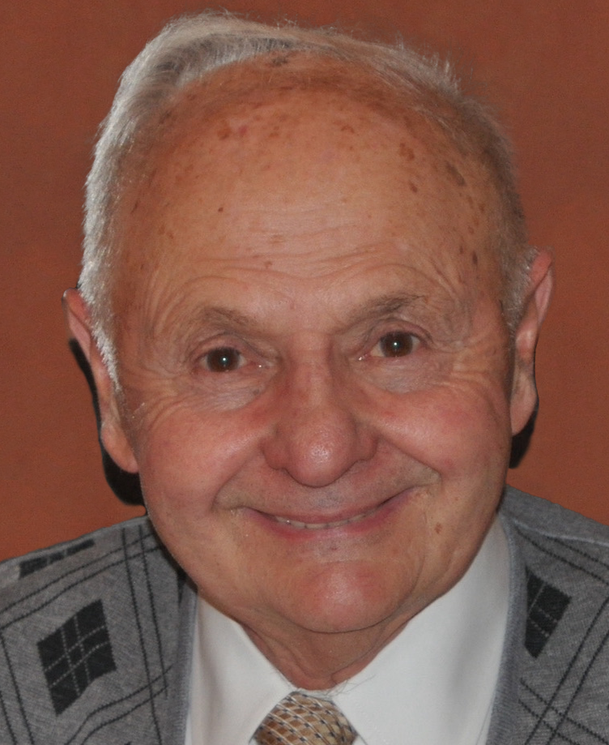

Benito F. Conca
January 1, 1934 – July 16, 2022

Our Lady of Mount Carmel Church
910 Birch Street
Boonton, NJ 07005

Thursday, July 21, 2022

Welcome
John Laurenzi
Gathering Song: We Walk by Faith
Pall Bearers
Frank Conca, Vincent Conca, Dennis Goldenberg,
Peter Scimenes, Thomas Laurenzi, John Laurenzi,
Chris Laurenzi

Placement of The Crucifix and The Book of The Gospel
Maria Peppard and Phyllis Goldenberg

Old Testament Reading: Wisdom 3: 1–6, 9
Nancy Scimenes
Thanks be to God.

Responsorial Psalm: Psalm 27: 1, 4, 7, 8b, 9a, 13–14
Refrain The Lord is my light and my salvation.

New Testament Reading: Romans 14: 7–9, 10c–12
Maria Volpe

Thanks be to God.

Gospel: John 14: 1–6
Praise to you, Lord Jesus Christ.

Prayers of the Faithful
Mark and Margarethe Laurenzi

Presentation of the Gifts
Patricia and Sandra Laurenzi

Preparation of The Gifts: Hosea

Communion Song: I Am the Bread of Life

Communion Meditation: Meditation from “Thaїs”
Isabelle Laurenzi, violin

Incensing of the Coffin

Recessional: Be Not Afraid

